S = 2Ns | Q(S) = S/(1-exp(-S)) | K = 2NuTpQ(s)/N | My calculation
5 | 5.033918275 | 0.042939323 | 0.311431744
2 | 2.313035285 | 0.019730191 | 0.071549891
1 | 1.581976707 | 0.013494261 | 0.048935813
0.9 | 1.516605975 | 0.012936649 | 0.046913678
0.8 | 1.452772977 | 0.012392153 | 0.044939111
0.7 | 1.390503705 | 0.011860997 | 0.043012915
0.6 | 1.329821529 | 0.011343378 | 0.041135813
0.5 | 1.270747041 | 0.010839472 | 0.039308442
0.4 | 1.213297913 | 0.010349431 | 0.037531349
0.3 | 1.157488774 | 0.009873379 | 0.035804986
0.2 | 1.103331113 | 0.009411414 | 0.034129709
0.1 | 1.050833194 | 0.008963607 | 0.032505773
0.05 | 1.025208325 | 0.008745027 | 0.031713111
This calculates the rate of adaptive substitution, K, for weakly advantageous mutations.Q(S) is N times the probability that a newly arising mutation with selective advantage S will fix (from Kimura).
I’m setting T = 4(2N) generations, which is estimated to be the time back to the common ancestor of the mel-sim split.
u = 5.8 * 10⁻⁸, which is 10X the value I got from Peter Andolfatto as the best estimate of the Drosophila mutation rate; this mutation rate is for a 10bp binding site.

N = 2 * 10⁶ as an estimate of the effective population size.

p is the probability that a mutation is adaptive, which I’ve set to 1/30 (one unique change in a 10bp binding site)

The idea here is to ask, what percentage of binding sites will have a slightly advantageous substitution in one lineage (the mel lineage) for a given level of selection intensity, S. It assumes that all sites are constrained completely except for one site, for which one particular base change will be slightly favored. What we see is that for very weak selection – nearly neutral really – we might expect to see a couple of percent of binding sites substituted. K doubles if two sites can have a slightly advantageous mutation.
So it is easy to account for the observed rate of binding site change with very weak selection. This fact doesn’t help us distinguish between the binding site turnover hypothesis or directional selection. But, I would argue, if there is a change in any component of the trans field, such as in the TF binding specificity (or optimum), such a change could only be fixed by selection if it has only very weak selective effect on each individual binding site or enhancer. In other words, it couldn’t reduce the fitness associated with any individual binding site by more than a nearly neutral amount. The calculation shows that very weak positive selection would produce the proportion of binding site changes we see on the mel lineage (1-2% for the strong binding energy changes).

Perhaps in retrospect this is obvious, but for me it was worth the simple calculation. A model of very weak selection, whether driven by turnover or by directional selection, can explain the observed pattern. It’s also easy to calculate the rate of substitution of slightly deleterious binding site substitutions. For a given S you can find the probability of a slightly deleterious substitution, p_{del}, (perhaps a higher proportion than p_{adap}) that would produce the observed ratio of binding energy changes you’ve actually observed (26 positive, 8 negative). Perhaps those negative ones are unavoidable for weak selection models, where both kinds of mutations are possible. Here’s the corresponding rate for slightly deleterious mutations (assuming it can only occur at one site and one specific change. Assuming that a few possible changes can be slightly deleterious, I think it can account for your data.

For deleterious mutations
S = 2Ns | Q(S) = S/(1-exp(-S)) | K = 2NuTpQ(s)/N
-5 | 0.033918275 | 0.000289323
-2 | 0.313035285 | 0.002670191
-1 | 0.581976707 | 0.004964261
-0.9 | 0.616605975 | 0.005259649
-0.8 | 0.652772977 | 0.005568153
-0.7 | 0.690503705 | 0.005889997
-0.6 | 0.729821529 | 0.006225378
-0.5 | 0.770747041 | 0.006574472
-0.4 | 0.813297913 | 0.006937431
-0.3 | 0.857488774 | 0.007314379
-0.2 | 0.903331113 | 0.007705414
-0.1 | 0.950833194 | 0.008110607
-0.05 | 0.975208325 | 0.008318527

Marty:

I did a calculation to estimate p_{adaptive}. Basically I’m asking if I randomly mutate a base pair in the inferred ancestral sequence of all the 704 ungapped sites (I excluded those positions where more than one binding site overlap since change in these positions can have pleiotropic effects, leaving 5129 sites in total), what’s the probability distribution of the effects of changes. I used a mutation matrix derived from sim polymorphism data (given to me by Jian in Wu lab). Below I plotted the cumulative distribution. From this I estimate that before selection 9% of the mutations will increase binding affinity by a significant amount and 71% will decrease the affinity by a significant amount.

I first attempted to use the formula and estimates you provided (Ne and u) to update the table. However I had problems reproducing the K values from Q(S) and the given Ne and u value. I showed my calculations in the added fourth column in the above table. If you can show me the excel file with formula, I’ll be able to figure out the discrepancy.

Some other problems related to the estimate. First of all, it seems that you are using a haploid model, because S=2Ns rather than 4Ns. If that’s the case, then K = NuTpQ(S)/N

Besides, I’m curious how you come up with an estimate of mel-sim split in the form of Ne, since my knowledge about estimating T is either from molecular clock calculations or from fossil records. But some rough estimation I did seem to suggest that this estimate of T=8Ne is probably not far off: if Ne = 2E6, u = 5.8E-9 and T = 8Ne, then k = uT = 5.8E-9*8*2E6 ≈ 10% Compare this to the genome estimate of 12% divergence in synonymous sites which suggest 6% on each lineage, maybe it is still reasonable?

Below is my calculation. I simply use 6% as the neutral rate, then multiply by 10%, which is the percentage of mutations estimated to be affinity-increasing, then multiply by Q(S), which is the relative fixation probability. However the numbers seem to suggest that the observed 26 (or 34 if include all the predicted affinity-increasing ones) is not very different from neutral.
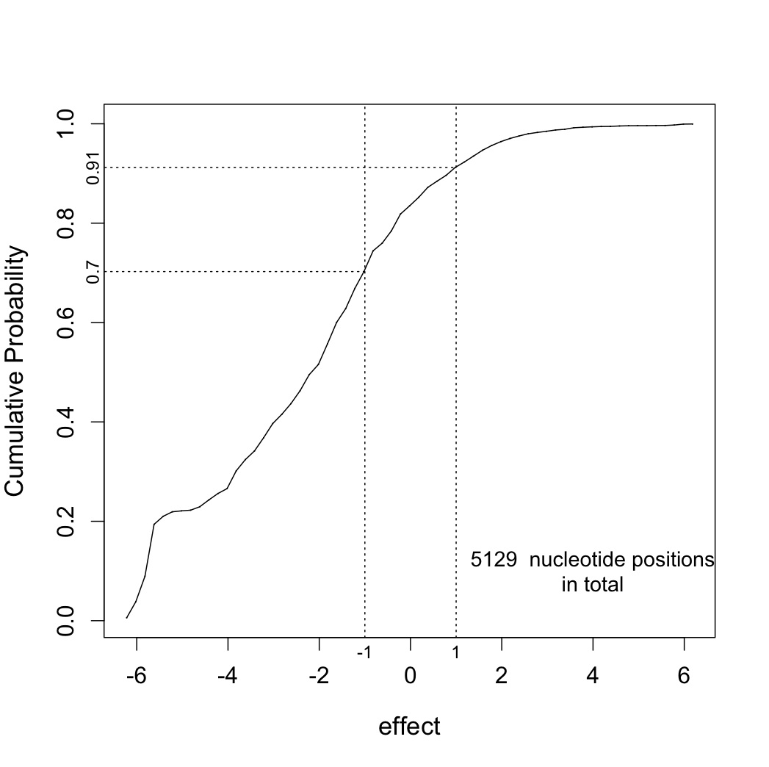
Positive
S = 2Ns | Q(S) = S/(1-exp(-S)) | K = 6%*10%*Q(S) | K * 5129
5 | 5.033918275 | 0.03020351 | 154.913801
2 | 2.313035285 | 0.013878212 | 71.18134788
1 | 1.581976707 | 0.00949186 | 48.68375118
0.9 | 1.516605975 | 0.009099636 | 46.67203229
0.8 | 1.452772977 | 0.008716638 | 44.70763559
0.7 | 1.390503705 | 0.008343022 | 42.791361
0.6 | 1.329821529 | 0.007978929 | 40.92392774
0.5 | 1.270747041 | 0.007624482 | 39.10596945
0.4 | 1.213297913 | 0.007279787 | 37.33802997
0.3 | 1.157488774 | 0.006944933 | 35.62055953
0.2 | 1.103331113 | 0.006619987 | 33.95391168
0.1 | 1.050833194 | 0.006304999 | 32.33834073
0.05 | 1.025208325 | 0.00615125 | 31.54976098

Negative
Negative
S = 2Ns | Q(S) = S/(1-exp(-S)) | K = 6%*70%*Q(S) | K * 5129
-5 | 0.033918275 | 0.001424568 | 7.306606863
-2 | 0.313035285 | 0.013147482 | 67.43343513
-1 | 0.581976707 | 0.024443022 | 125.3682582
-0.9 | 0.616605975 | 0.025897451 | 132.828026
-0.8 | 0.652772977 | 0.027416465 | 140.6190491
-0.7 | 0.690503705 | 0.029001156 | 148.746927
-0.6 | 0.729821529 | 0.030652504 | 157.2166942
-0.5 | 0.770747041 | 0.032371376 | 166.0327861
-0.4 | 0.813297913 | 0.034158512 | 175.1990098
-0.3 | 0.857488774 | 0.036014529 | 184.7185167
-0.2 | 0.903331113 | 0.037939907 | 194.5937817
-0.1 | 0.950833194 | 0.039934994 | 204.8265851
-0.05 | 0.975208325 | 0.04095875 | 210.0774269

